Criteria VI: Governance, Leadership and Management

Metric: 6.5.3 Quality assurance initiatives of the institution include: 1. Regular meeting of Internal Quality Assurance Cell (IQAC); Feedback collected, analysed and used for improvements 2. Collaborative quality initiatives with other institution(s) 3.Participation in NIRF 4.Any other quality audit recognized by state, national or international agencies (ISO Certification)

Query: Provide ISO certificate/NBA certificate or quality certificate from any recognized state/national/international agencies for the assessment period.

Response:
- NBA, NAAC, NABL, NIRF, ISO, ARIIA, IIC certificates during the assessment period
S.NO | QUALITY CERTIFICATIONS | PAGE NUMBER
 | ISO | 02
 | NBA | 03
 | NAAC | 38
 | NABL | 39
 | NIRF | 40
 | ARIIA | 45
 | IIC | 46

ISO CERTIFCATION

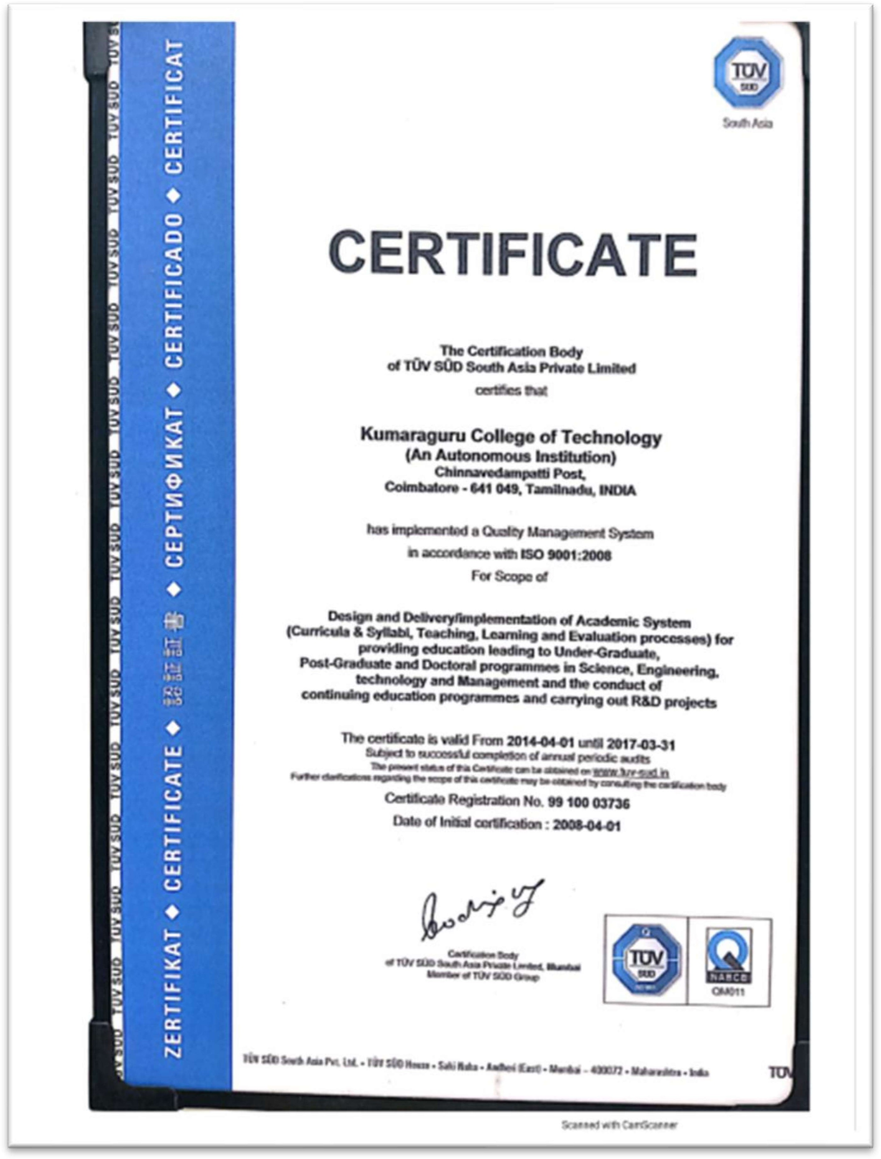

S. No. | NBA Accredited Programmes | Period of Accreditation | Letter number with Date of Issue
1 | B.E. Civil Engineering | [1.7.2019 to 30.6.2022] [1.1.2018 to 30.6.2019] [1.1.2016 to 31.12.2018] | Granted extension of accreditation for 3 years vide letter F.No.33-117/2010-NBA, dated 29/3/2019 ; 26/09/2016 & 15/04/2016
2 | B.E. Electrical and Electronics Engineering
3 | B.E. Electronics and Communications Engineering
4 | B.E. Computer Science & Engineering
5 | B.Tech. Information Technology
6 | B.Tech. Fashion Technology | [1.7.2021 to 30.6.2022] [1.7.2020 to 30.6.2021]  [1.7.2019 to 30.6.2020]  [1.7.2014 to 30.6.2019] | Granted extension of accreditation for 1 year vide letter F.No.33-117/2010-NBA, dated 05/8/2021; 11.09.2020;30.05.2019;13.10.2014
7 | B.Tech. Biotechnology | [1.7.2021 to 30.6.2022] [1.7.2020 to 30.6.2021]  [Up to 30.06.2022]  [1.7.2017 to 30.6.2020] [1.7.2016 to 30.6.2017] [1.7.2014 to 30.6.2016] | Granted extension of accreditation for 1 year vide letter F.No.33-117/2010-NBA, dated 15/9/2021;  11.09.2020; 04.11.2019; 11.06.2018; 08.07.2016;13.10.2014
8 | B.E. Mechanical Engineering | [1.7.2019 to 30.6.2022] | Granted Accreditation for 3 years vide letter F.No.33-117/2010-NBA, dated 4/11/2019
9 | B.E. Mechatronics Engineering
10 | B.E. Electronics & Instrumentation Engineering
11 | B.E. Aeronautical Engineering
12 | B. Tech. Textile Technology | [1.7.2019 to 30.6.2022]  [18.9.2013 to 17.9.2018] | Granted Accreditation for 3 years vide letter F.No.33-117/2010-NBA, dated 31/1/2020; 30.09.2013
13 | M.B.A. | [1.7.2019 to 30.6.2022] | Granted Accreditation for 3 years vide letter F.No.33-117/2010-NBA, dated 14/10/2019
14 | M.Tech. Biotechnology | [1.7.2019 to 30.6.2022] | Granted Accreditation for 3 years vide letter F.No.33-117/2010-NBA, dated 4/11/2019

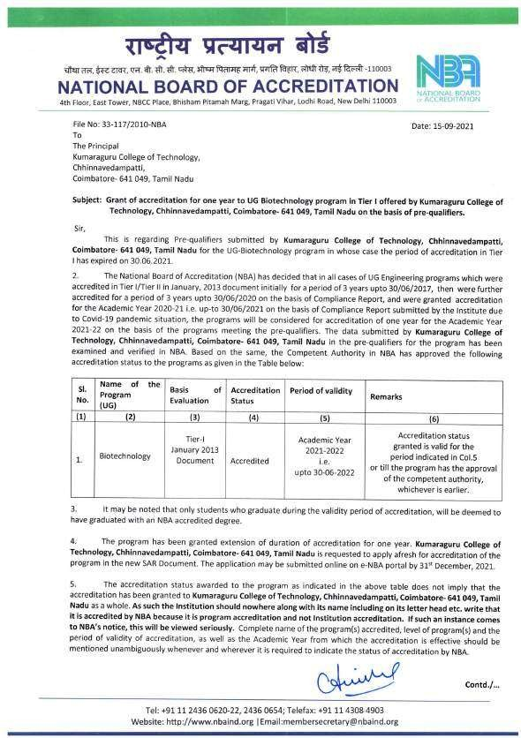

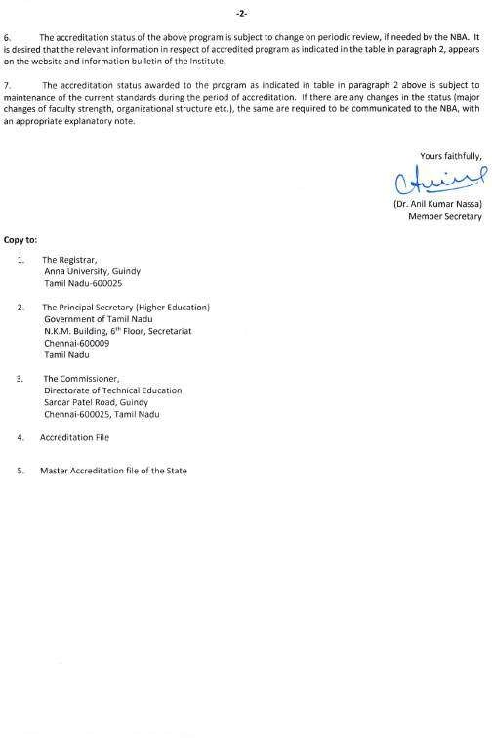

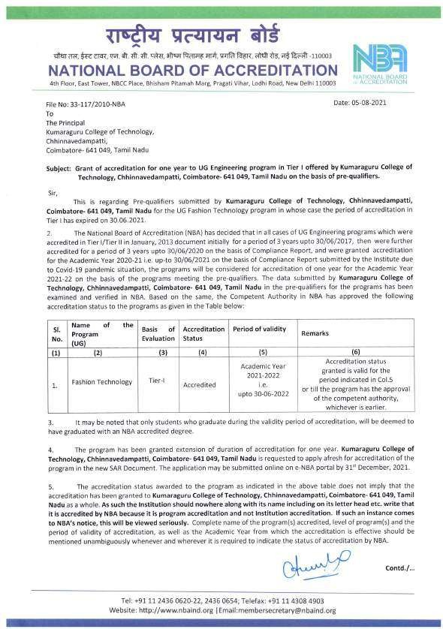

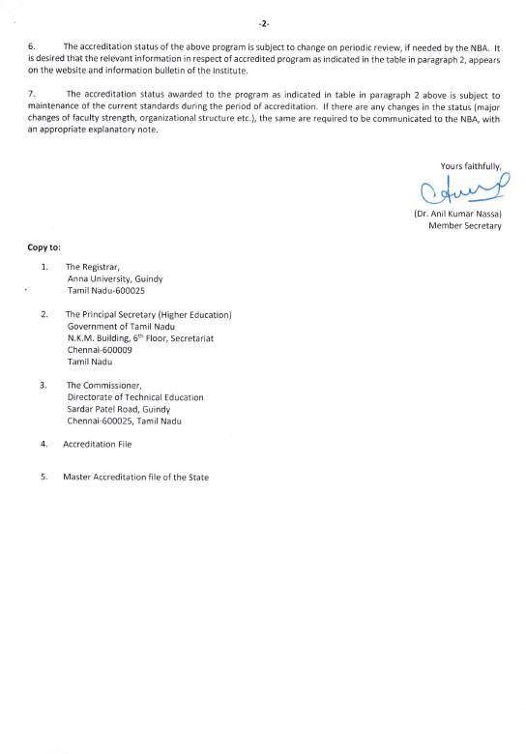

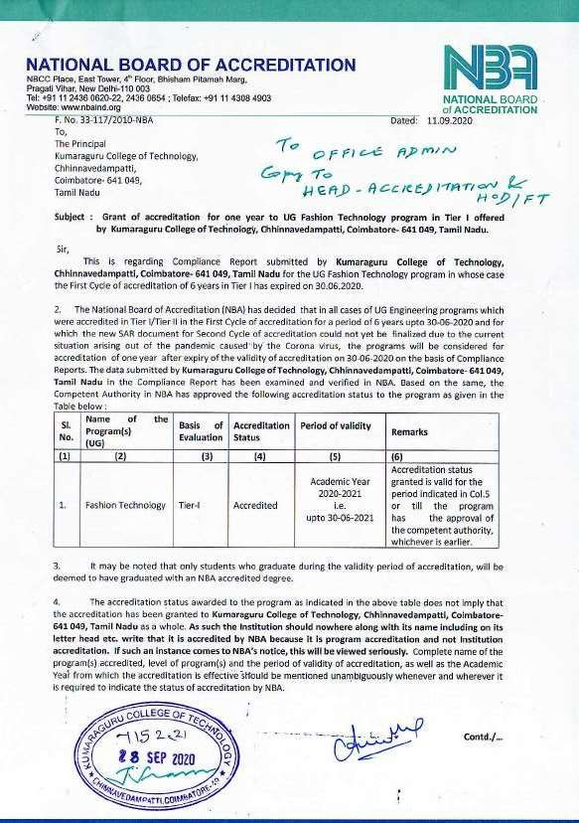

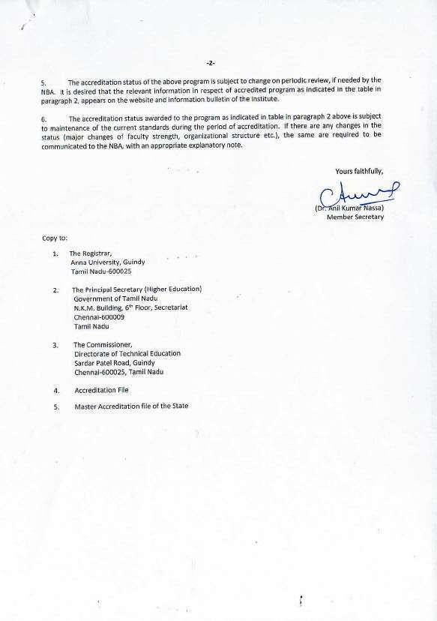

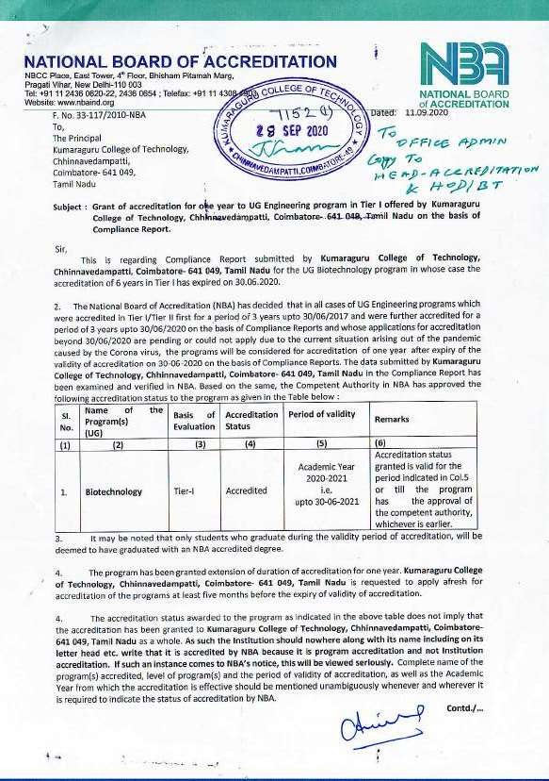

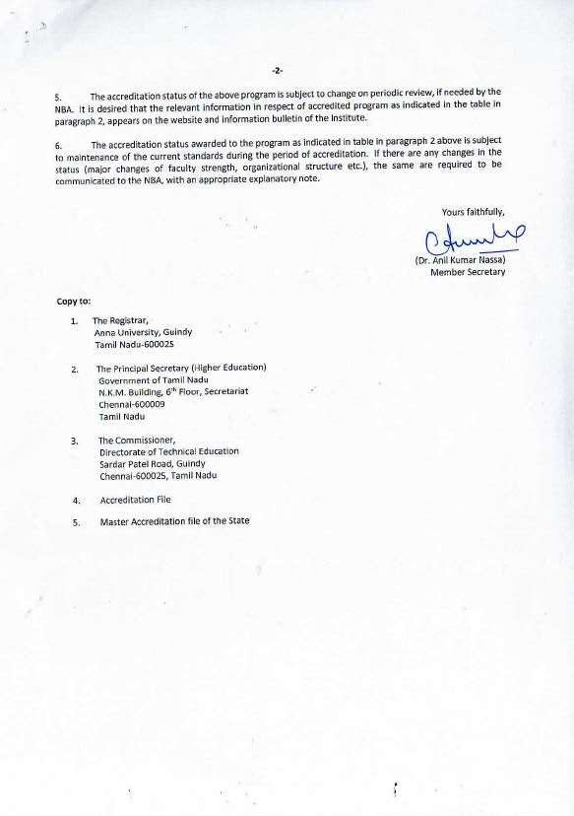

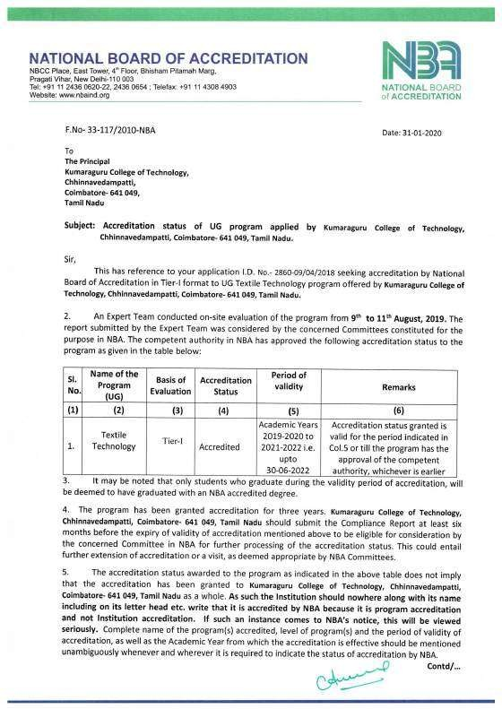

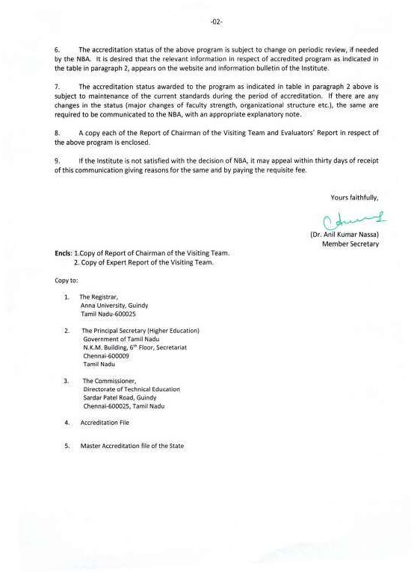

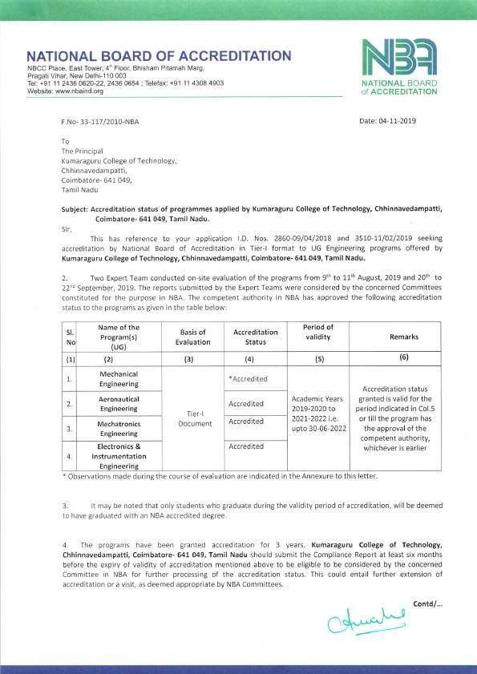

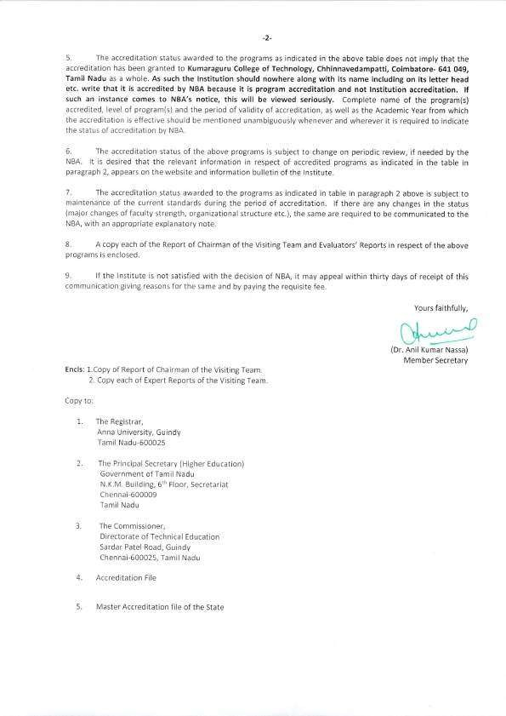

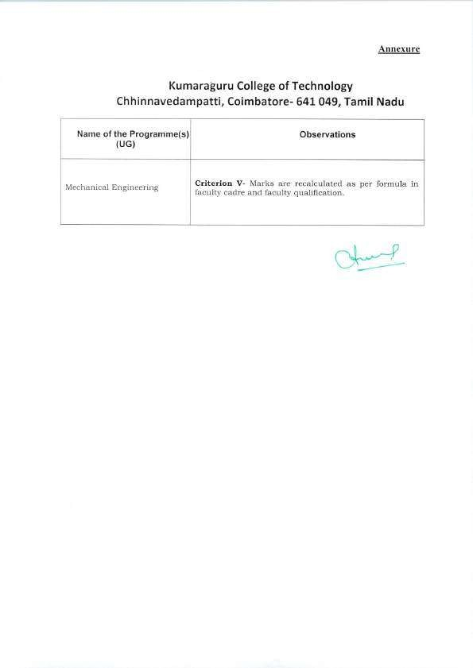

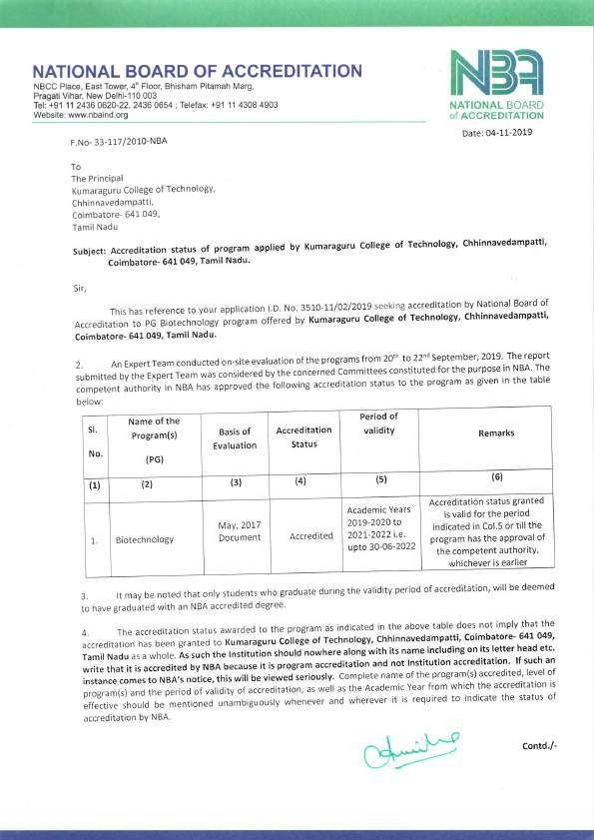

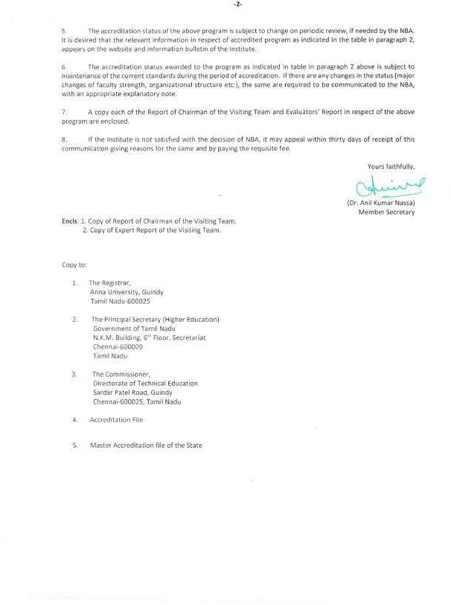

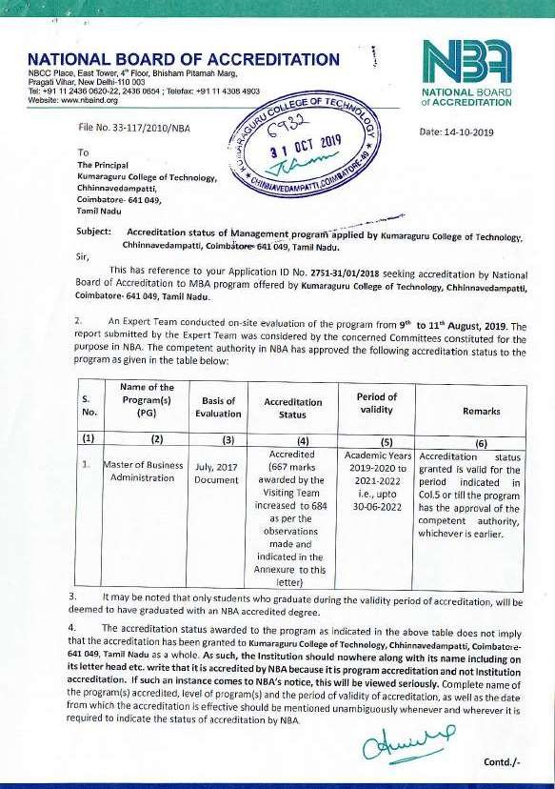

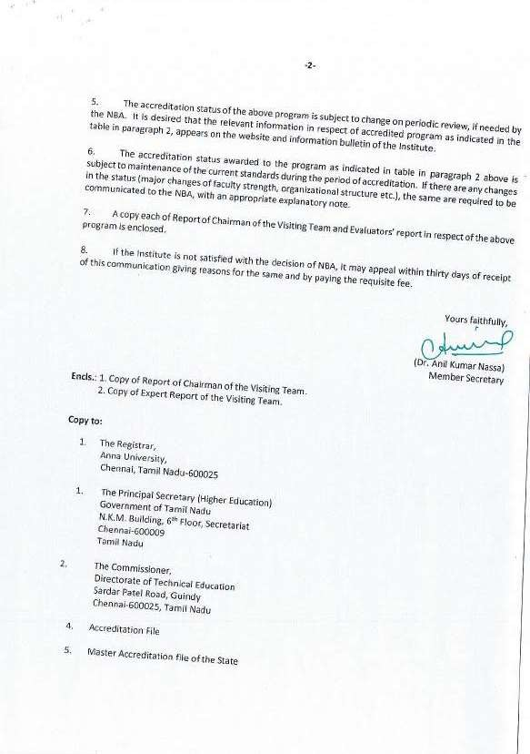

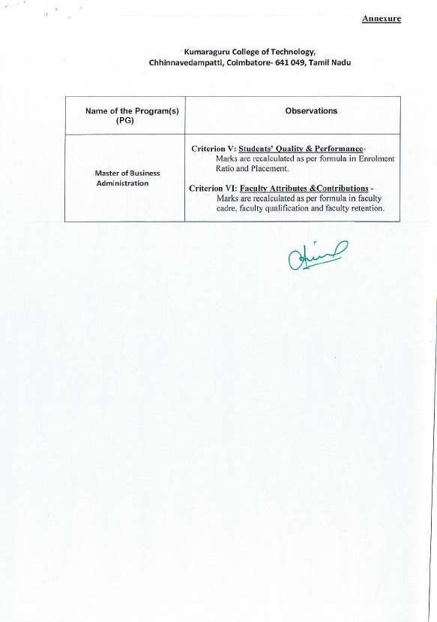

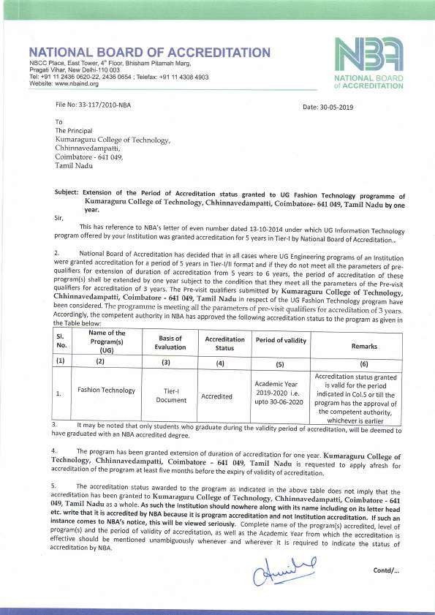

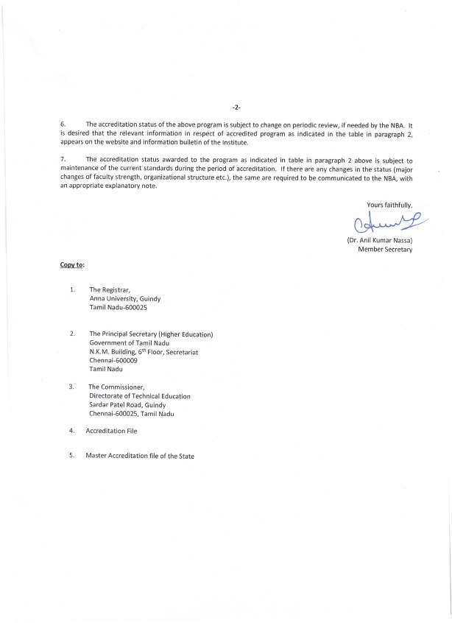

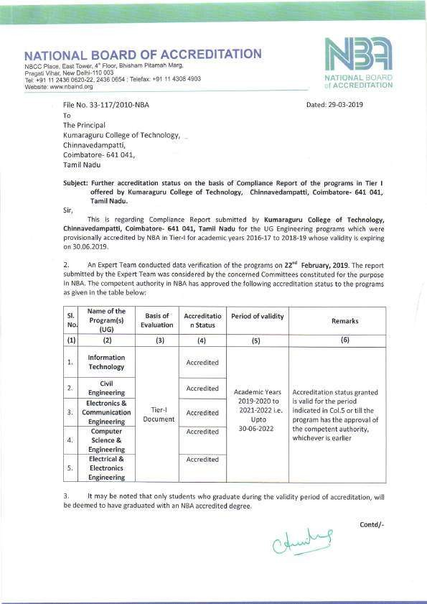

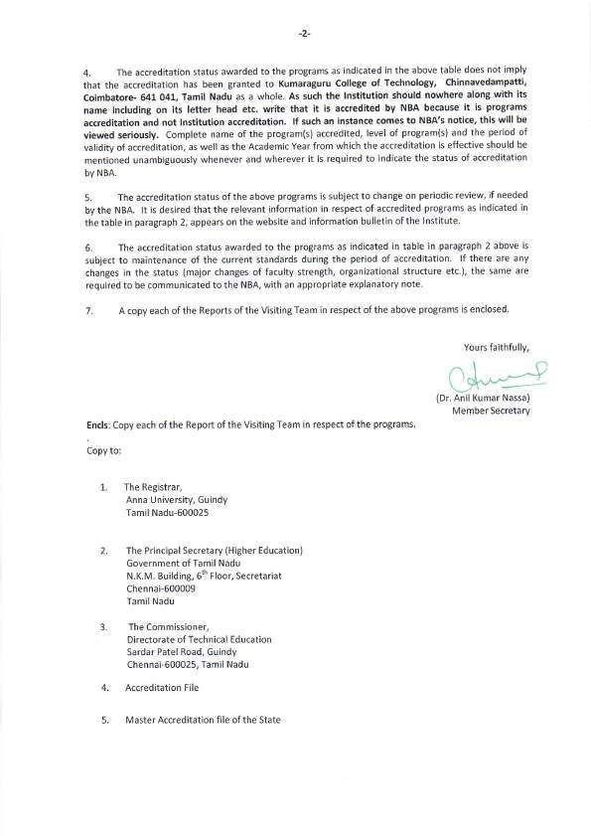

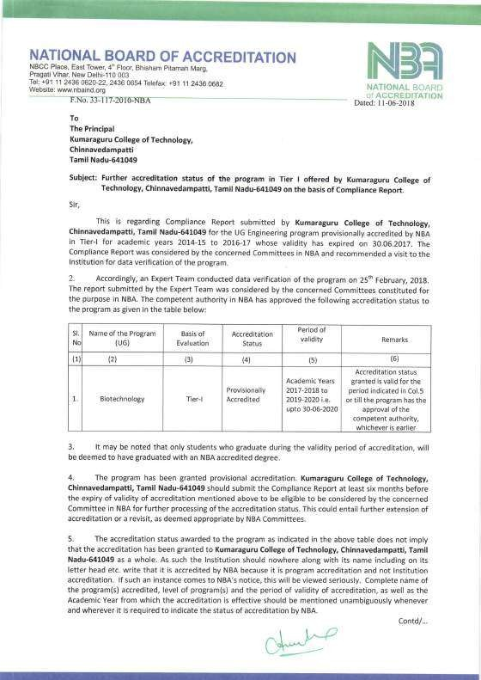

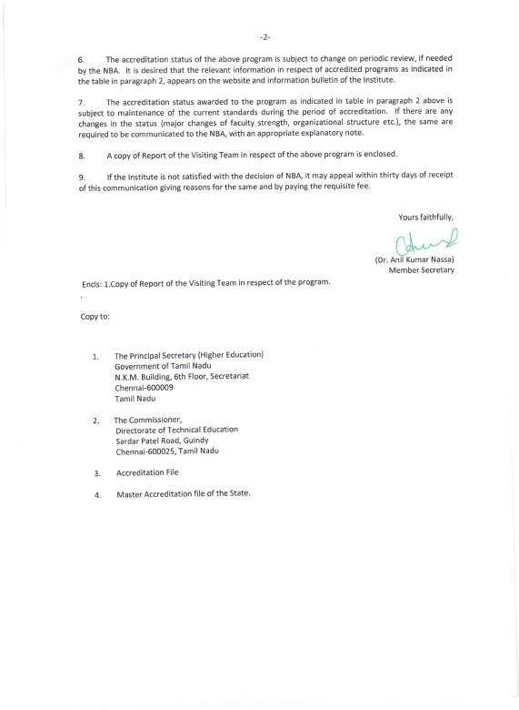

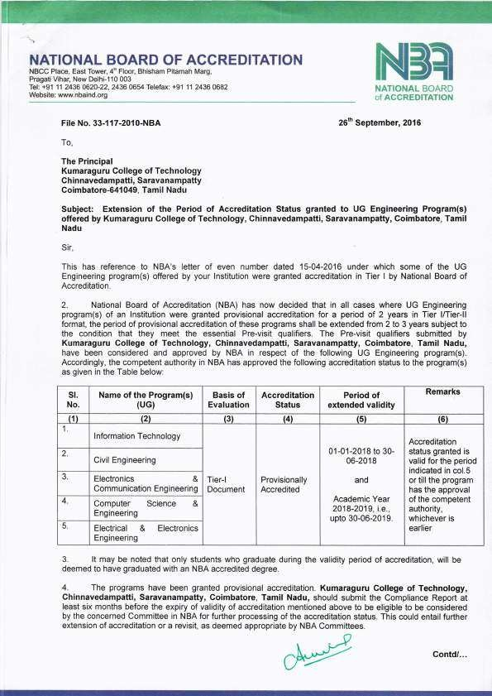

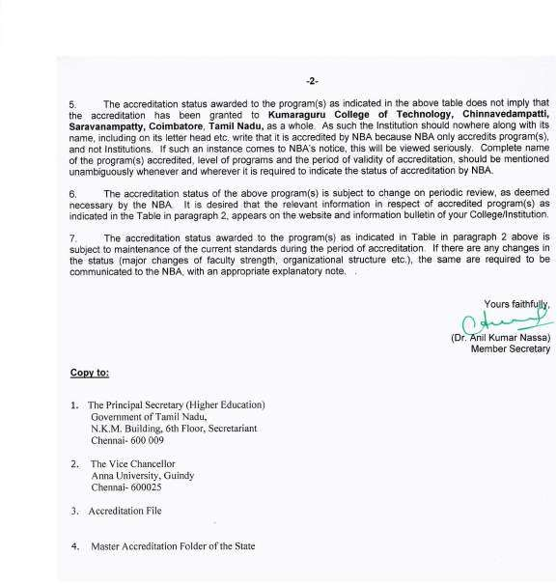

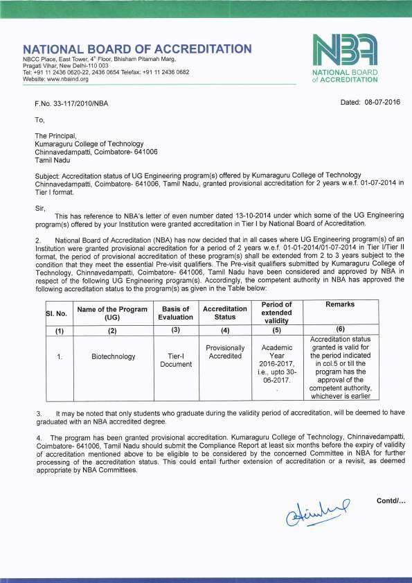

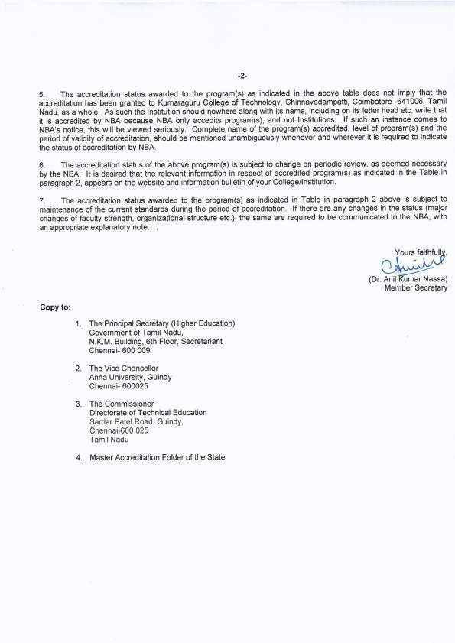

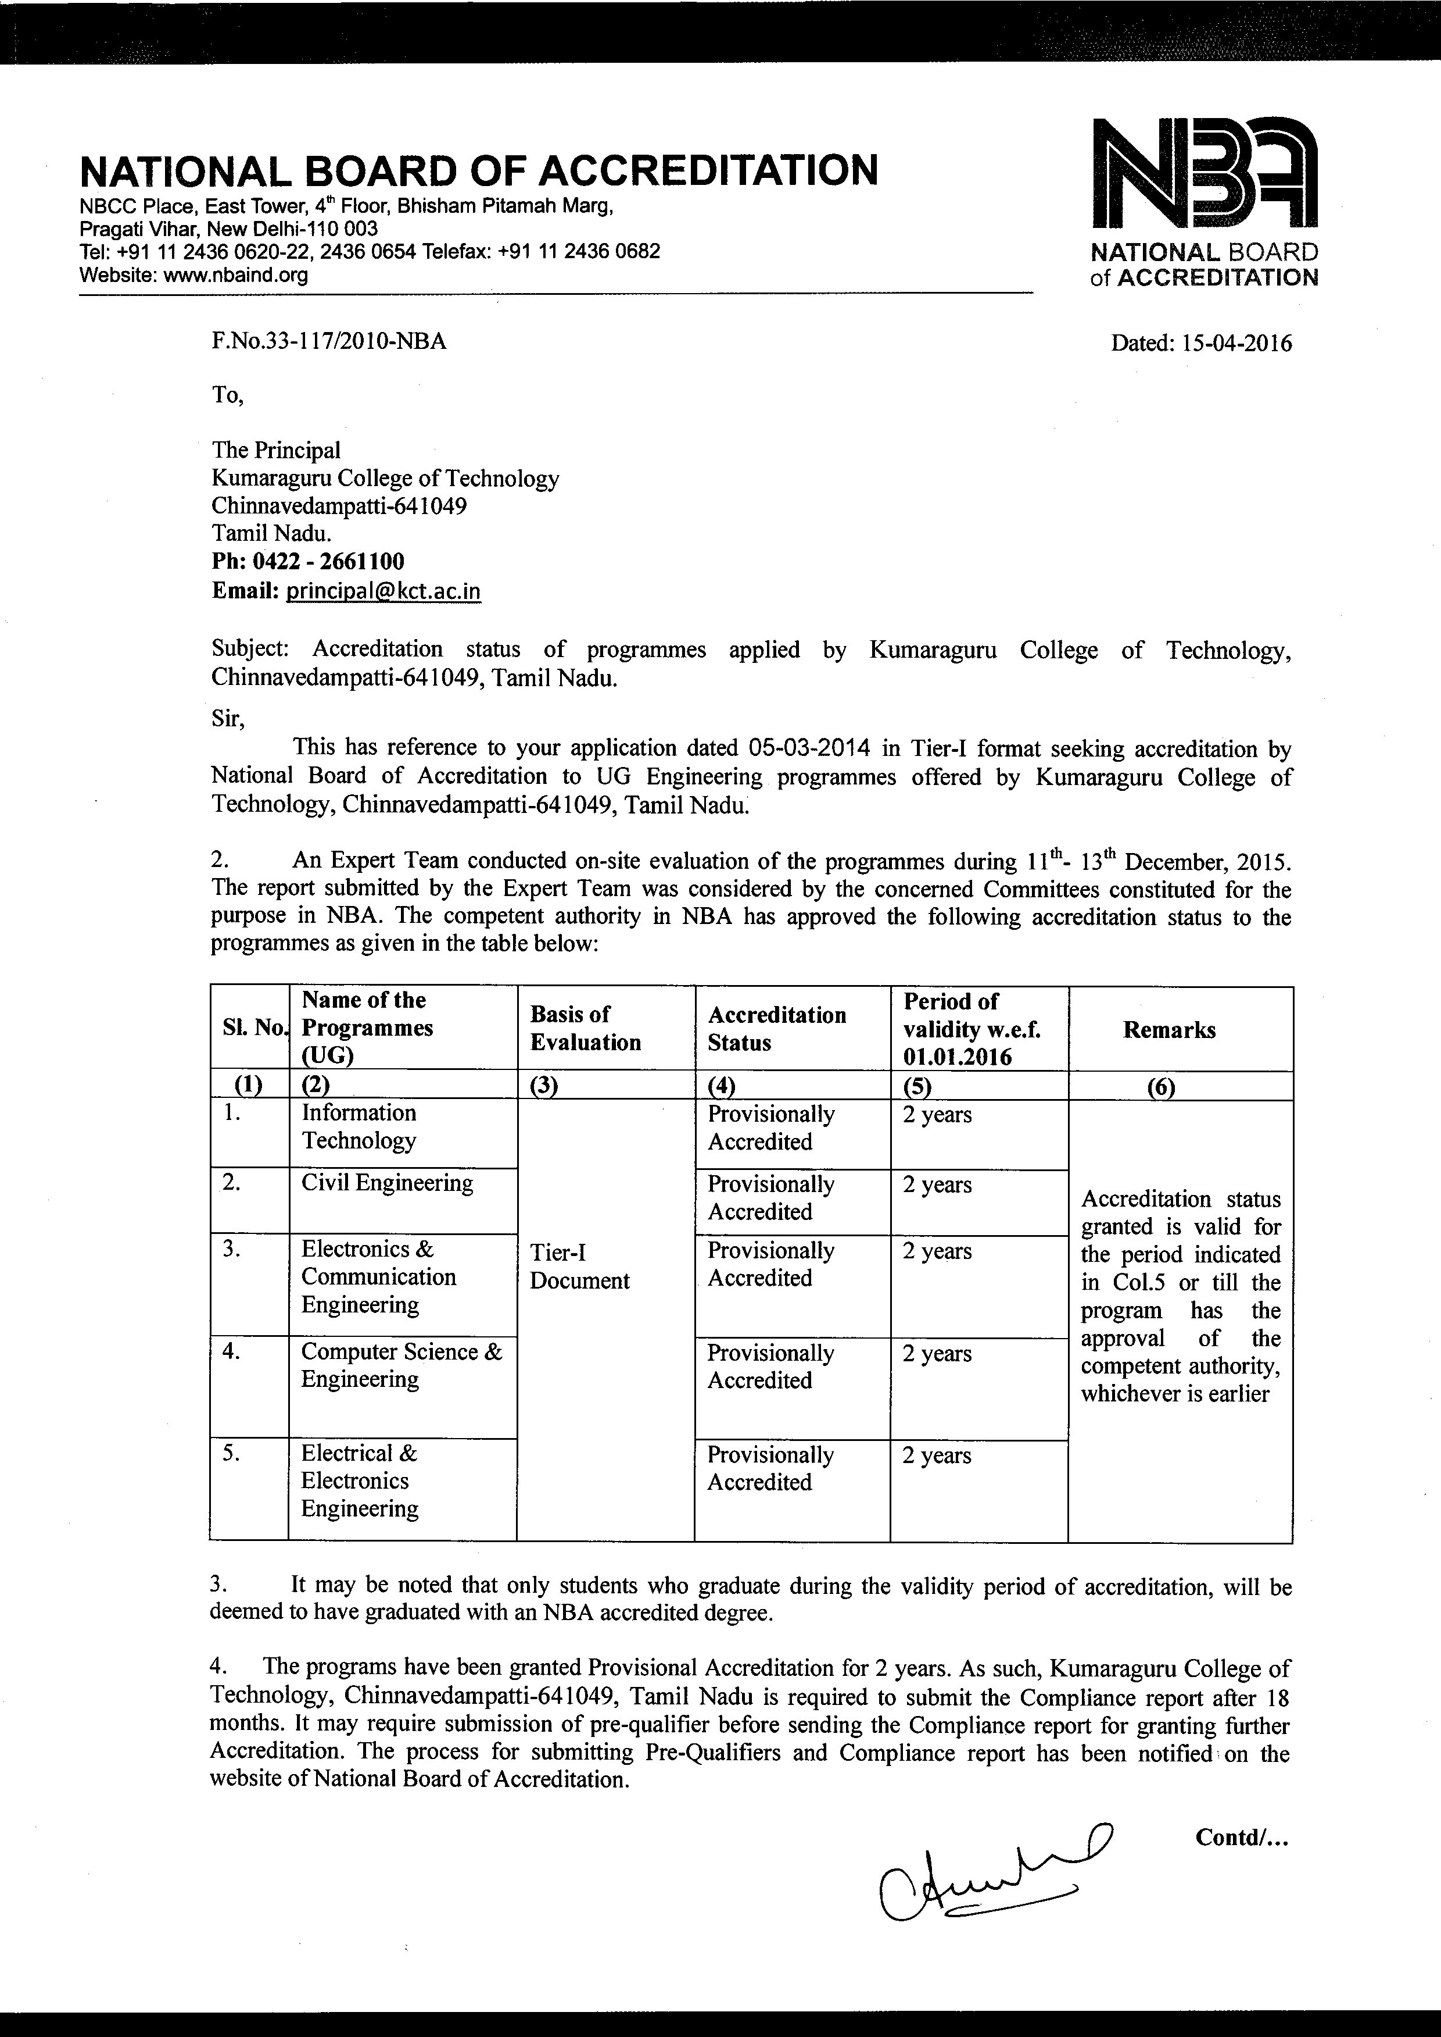

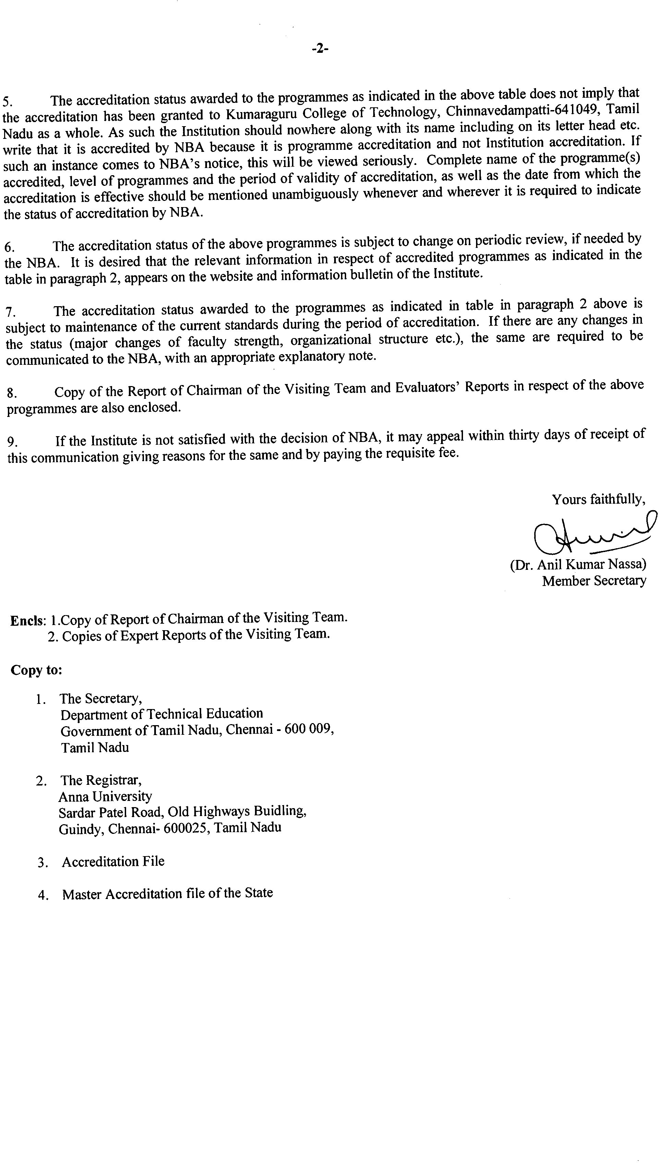

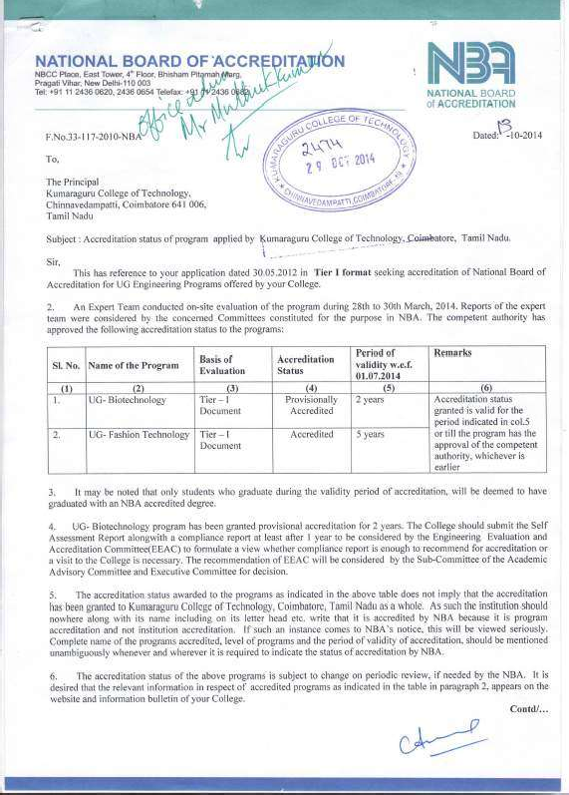

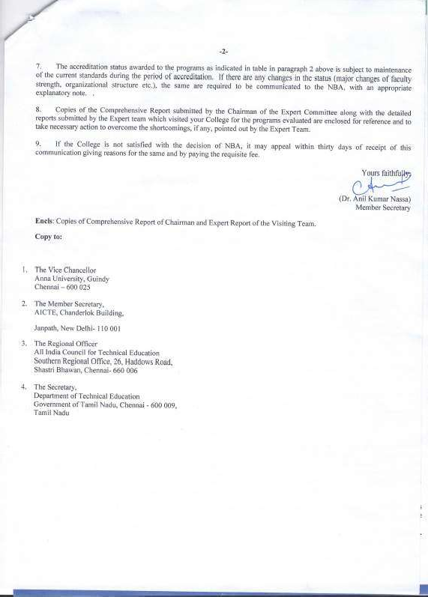

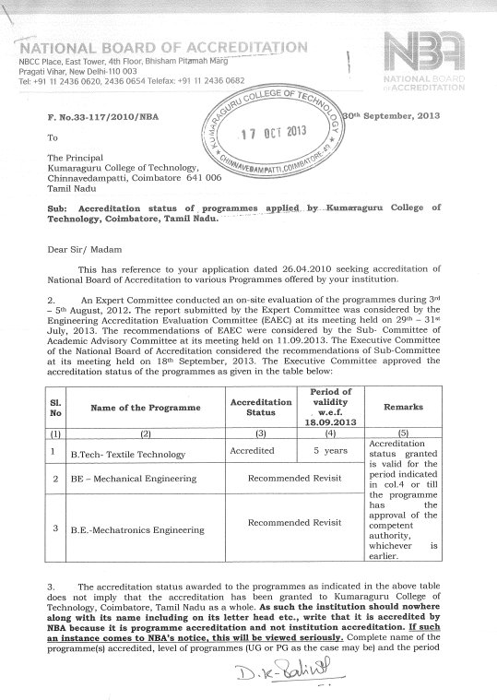

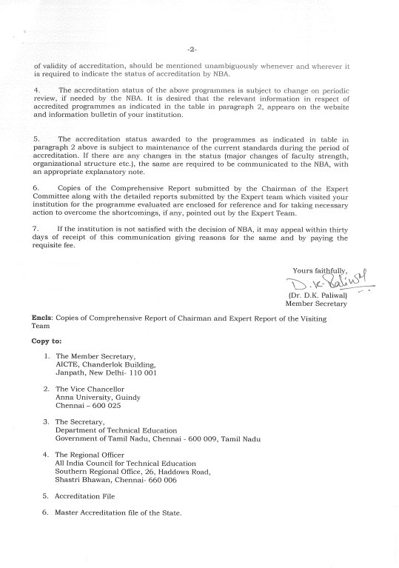
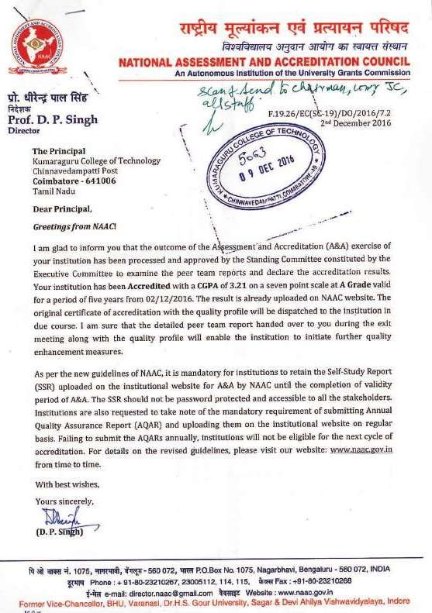
NAAC

NABL

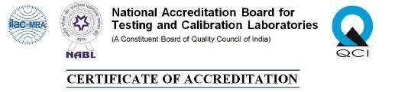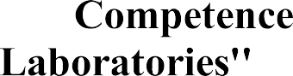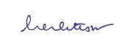

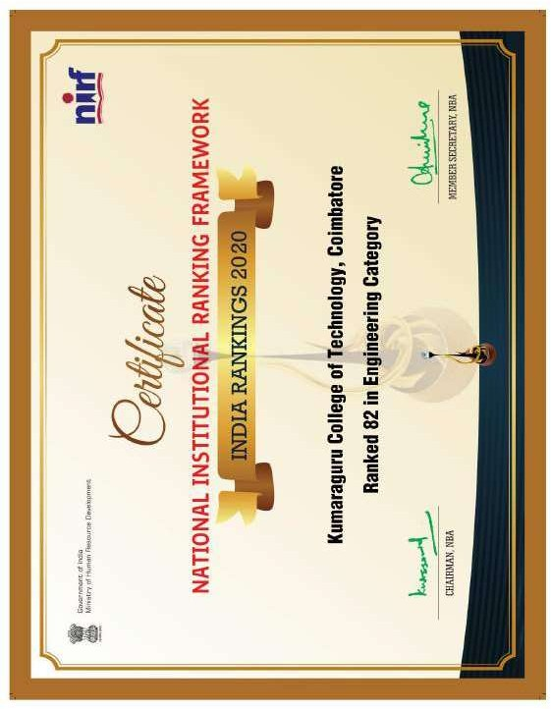

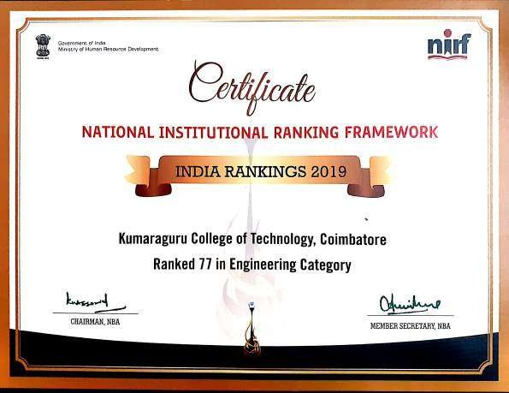

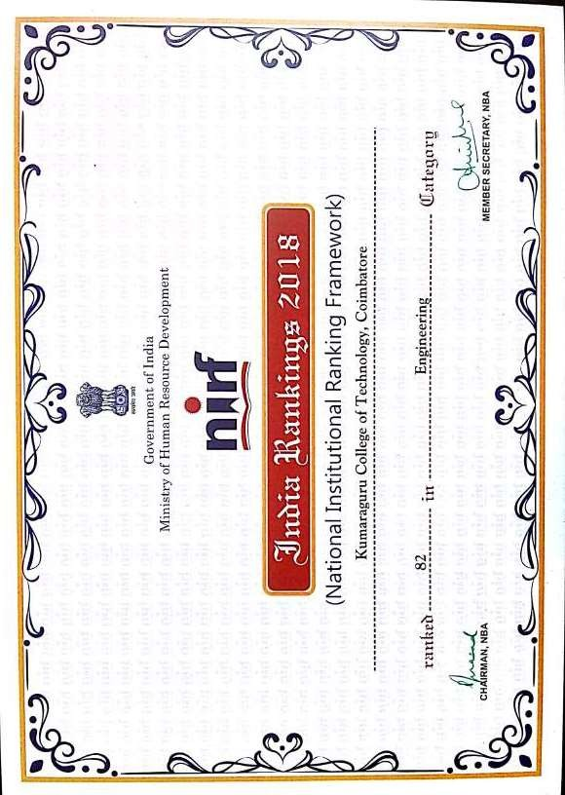

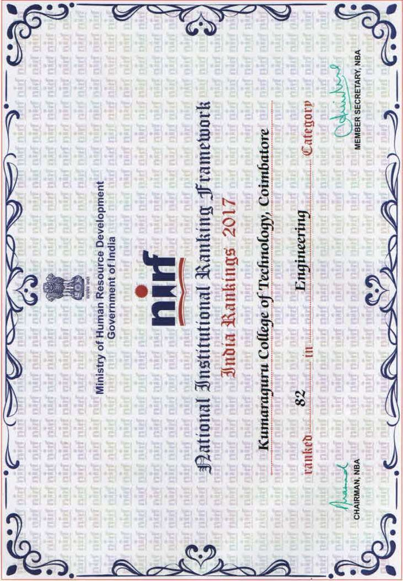

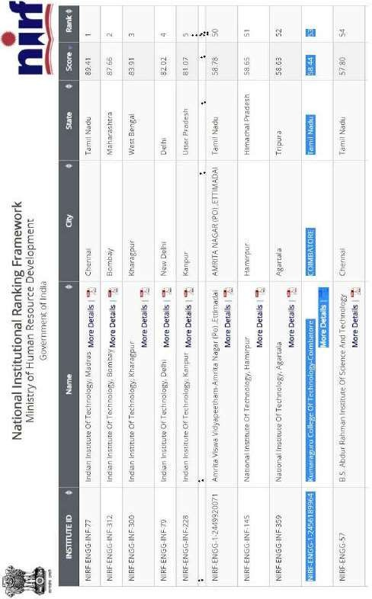

ARIIA

ARIIA

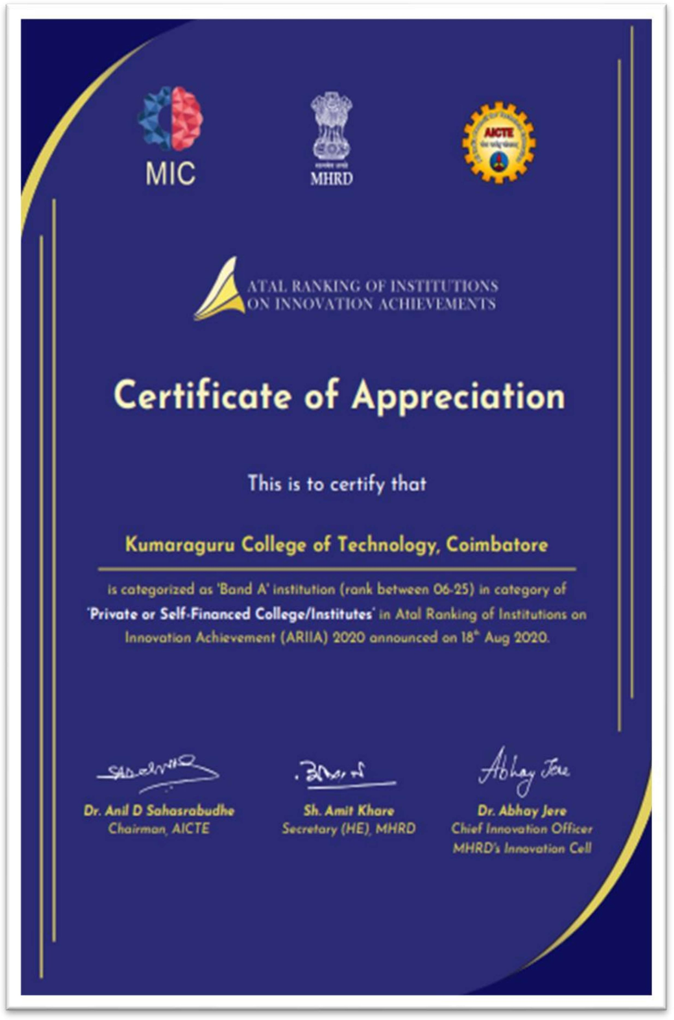

IIC

